**ACTUATION SYSTEMS**

***PROJECT OBJECTIVES:***

* To learn about the actuation system.
* To learn about its components and their working.
* To study its purpose and advantages.

***ACTUATION SYSTEM:***

The actuation system is used to guide a missile or any aircraft. . The role of actuation system in a missile is to control it and guide it to the desired or designed path. The actuation system is comprised of many components.

The purpose of the actuation system is to control the missile i.e.

1. TVC (Thrust vector control).

2. ADC (Aerodynamic control). etc

**The types of the actuation system are divided based upon its working medium.**

**The different types of actuation system are:**

1. Pneumatic actuation system (air is working medium).

2. Hydraulic actuation system (hydraulic oil as working medium).

3. Electric actuation system (electric motor).

**The components of the Hydraulic actuation system are:**

* Actuator.
* Servo valve.
* Bootstrap reservoir.
* Accumulator.
* Non return valve.
* High and low pressure filters.
* Pressure transducer.
* High and low pressure relief valves.
* Pump Motor Package.
* Solenoid valve.
* Hoses

**ACTUATOR:**

A mechanism to activate process control equipment by use of pneumatic, hydraulic, or electronic signals; for example, a valve actuator for opening or closing a valve to control the rate of fluid flow.

An **actuator** is a type of [motor](http://en.wikipedia.org/wiki/Motor) for moving or controlling a mechanism or system. It is operated by a source of energy, usually in the form of an electric current, [hydraulic fluid](http://en.wikipedia.org/wiki/Hydraulic_fluid) pressure or [pneumatic](http://en.wikipedia.org/wiki/Pneumatic) pressure, and converts that energy into some kind of motion. An actuator is the mechanism by which an agent acts upon an environment. The agent can be either an artificial intelligence agent or any other autonomous being.

A mechanical, electrical, or hydraulic device, or their combination, used to effect some predetermined linear, rotary, or oscillating movement. An actuator essentially converts hydraulic or air pressure into mechanical force. Basically, there are two types of actuators: single-acting and double-acting. In the single-acting actuator, the piston moves in a single direction as a result of system pressure. In a double-acting system, the actuator’s piston moves in either direction. The fluid enters from one side of the piston and is drained out of the other. The double-acting actuator may be balanced or unbalanced. In the former case, movement in both directions is equal, whereas in the latter case, the movement to one side is greater than the other.

**The body of the actuator:**

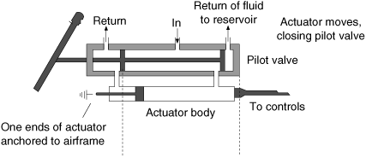

**HYDRAULIC ACTUATION SYSTEM:**

Hydraulic Actuators, as used in industrial process control, employ hydraulic pressure to drive an output member. These are used where high speed and large forces are required. The fluid used in hydraulic actuator is highly incompressible so that pressure applied can be transmitted instantaneously to the member attached to it.

It was not, however, until the 17th century that the branch of hydraulics with which we are to be concerned first came into use. Based upon a principle discovered by the French scientist Pascal, it relates to the use of confined fluids in transmitting power, multiplying force and modifying motions.

Then, in the early stages of the industrial revolution, a British mechanic named Joseph Bramah utilized Pascal’s discovery in developing a hydraulic press. Bramah decided that, if a small force on a small area would create a proportionally larger force on a larger area, the only limit to the force a machine can exert is the area to which the pressure is applied.

**Principle Used in Hydraulic Actuator System**

**Pascal’s Law**

Pressure applied to a confined fluid at any point is transmitted undiminished and equally throughout the fluid in all directions and acts upon every part of the confining vessel at right angles to its interior surfaces.

**Amplification of Force**

Since pressure P applied on an area A gives rise to a force F, given as,

F = P×A

Thus, if a force is applied over a small area to cause a pressure P in a confined fluid, the force generated on a larger area can be made many times larger than the applied force that created the pressure. This principle is used in various hydraulic devices to such hydraulic press to generate very high forces.

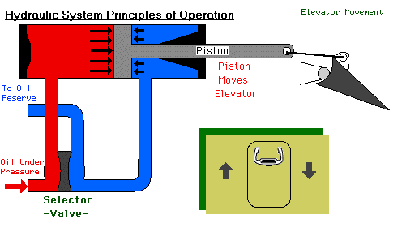

* A valve is opened, the hydraulic flows into the actuator and presses against the piston, causing it to move and in turn move the attached control surface

**ADVANTAGES OF THE HYDRAULIC ACTUATION SYSTEM:**

Variable hydraulic actuators are widely used as drives of machine tools, rolling mills, pressing and the foundry equipment, road and building machines, transport and agricultural machines, etc. A number of **advantages** in comparison with mechanical and electric transfers explain such their wide application:

* Infinitely variable control of gear-ratio in a wide range and an opportunity to create the big reduction ratio.
* Small specific weight, i.e. the weight of a hydro actuator is in ratio to transmitted capacity (0, 2...0, 3 kg / kWt).
* Opportunity of simple and reliable protection of the engine from overloads;
* Small sluggishness of the rotating parts, providing fast change of operating modes (start-up, dispersal, a reverser, a stop).
* Simplicity of transformation of rotary movement into reciprocating one.

Opportunity of positioning a hydraulic engine on removal (distance) from an energy source and freedom in making configuration

**DISADVANTAGES:**

It is also necessary to reckon with **disadvantages** of hydraulic actuators:

Efficiency of a volumetric hydraulic actuator is a little bit lower, than efficiency of mechanical and electric transfers, and during regulation it is reduced.

* Conditions of operation of a hydraulic actuator (temperature) influence its characteristics.
* Efficiency of a hydraulic actuator is a little reduced in the process of exhaustion of its resource owing to the increase in backlashes and the increase of outflow of liquid (falling of volumetric efficiency).
* Sensitivity to pollution of working liquid and necessity of high culture service.

**GENERAL USES**

* Used for flight control, actuation of flaps, slats, weapons bays, landing gear, breaks
* Provides the extra force required to move large control surfaces in heavy aerodynamic loads.

**Problems with Hydraulics:**

* Heavy
* High maintenance

(Ads cost and creates a logistics problem)

* Requires space (pumps, hydraulic lines, etc.)

***PNEUMATIC ACTUATION SYSTEM:***

The pneumatic actuation is similar to that of the hydraulic actuation system but the difference is the working medium i.e. air. The piston movement in the actuator is done with the air pressure. The piston in the cylinder is driven by the air pressure two ports are available at the two ends of the cylinder for exerting the air pressure with respect to the required movement of the piston whether it is upwards or downwards.

As compressed air moves into the cylinder, it pushes the piston along the length of the cylinder. Compressed air or the spring, located at the rod end of the cylinder, pushes the piston back.

**Pneumatic Actuator:**

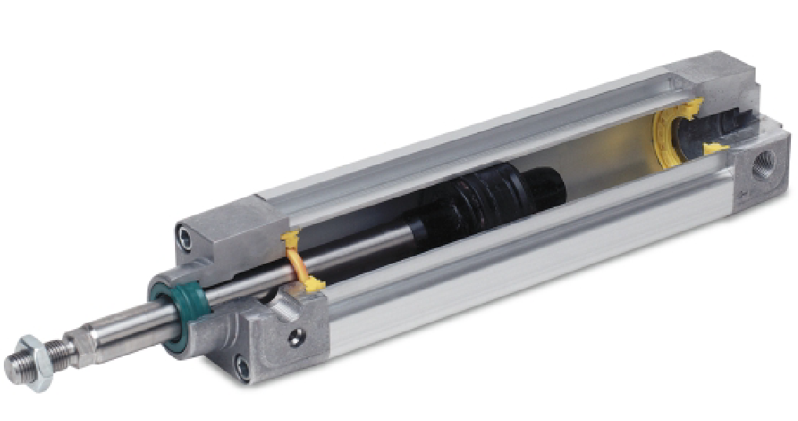

**Optimal range:**

* Good running performance and long service life thanks to smooth, hard cylinder bore
* Piston rod and cylinder barrel made of stainless steel

**More than the standard:**

* Round cylinders with piston diameters from 8 to 25 mm conform to ISO 6432, DIN ISO 6432. Variants are based on these standards. The series is not repairable.
* The cap is swaged onto the barrel.

**Functional:**

Three different end caps mean numerous functional and spacesaving designs

Variants

* Non-rotating
* Through piston rod
* With or without position sensing

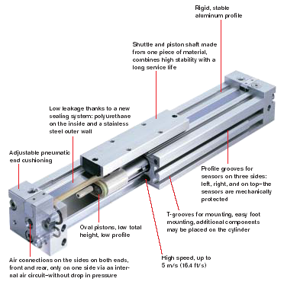

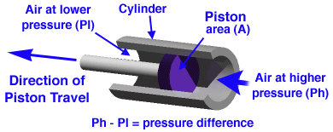

The pneumatic actuation system acts on the gas laws,

**The combined gas law:**



**The ideal gas law:**

* **P** is the pressure in atmospheres (atm) or kilopascals (kPa);
* **V** is the volume in liters
* **n** is the number of moles of gas
* **R** is the ideal gas constant in L atm/mol K or Pa m³/mol K

**T** is the temperature in kelvins

**Boltzmann’s equation:**





* The strings and are the Kinetic Energy
* **m** refers to the mass of one atom
* **< c2 >** refers to the average of c2
* **k** refers to the Boltzmann constant
* **T** refers to the temperature of the surroundings

**Classification of pneumatic actuators**:

A set of devices into with one or more pneumo engines, which are determined to start mechanisms or some other objects by means of pressed working gas is called pneumatic actuator, or pneumo actuator.

The devices intended for transformation of potential and kinetic energy of the stream of compressed gas in mechanical energy of the output link that can be, for example, a rod of the piston, a shaft of the turbine or the case of the jet device is called pneumatic engines of the automated actuator.

**All pneumatic actuators can be subdivided into the following types:**

• Diaphragm pneumatic actuators;

• Pneumatic power cylinders;

• Gas-engine pneumatic actuators;

• Turbine pneumatic actuators;

• Jet-stream pneumatic actuators;

• Pneumomuscles;

• Combined pneumatic actuators.

The principle of transformation of potential or kinetic energy of the gas stream into mechanical energy of the engine output link of the engine provides the base for division into types.

**All pneumatic actuators can be subdivided into the following types:**

**Diaphragm pneumatic actuators:**

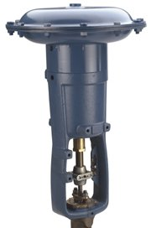

**Pneumatic power cylinders:**

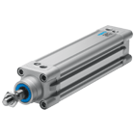

**Turbine pneumatic actuators:**

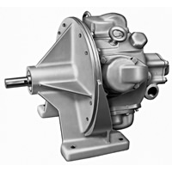

**Jet pneumatic actuators:**

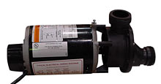

**Pneumomuscles:**

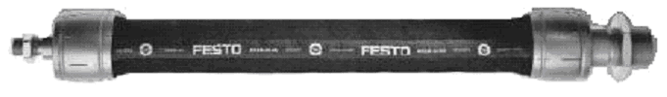

**Combined pneumatic actuators:**

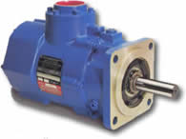

**Advantages:**

* Simplicity of realization relatively to small back and forth motions;
* Sophisticated transfer mechanisms are not required
* Low cost
* High speed of moving
* Ease at reversion movements
* Tolerance to overloads, up to a full stop.
* High reliability of work
* Explosion and fire safety
* Ecological purity
* Ability to accumulation and transportation

**Disadvantages:**

* Compressibility of the air
* Impossibility to receive uniform and constant speed of the working bodies movement
* Difficulties in performance at slow speed
* Limited conditions – use of compressed air is beneficial up to the definite values of pressure (the cost of compressed air production increases sharply when the pressure in the system exceeds 8…10 bar)
* Compressed air requires good preparation (the air should be cleared of mechanical impurity and should be free of moisture)

***ELECTRIC ACTUATION SYSTEM:***

Electrically Actuated systems are widely used in control systems because they are easy to interface with the control systems which are also electric and because electricity is easily available unlike fluid power which requires pumps and compressors.

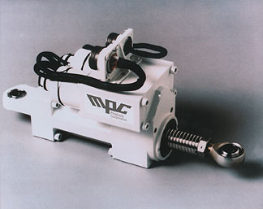

**The advantages of electric systems are:**

* Electricity is easily routed to the actuators; cables are simpler than pipe work.
* Electricity is easily controlled by electronic units.
* Electricity is clean.
* Electrical faults are often easier to diagnose.

**The disadvantages of electric actuators are:**

* Electrical equipment is more of a fire hazard than other systems unless made intrinsically safe, in which case it becomes expensive.
* Electric actuators have a poor torque - speed characteristic at low speed.
* Electric actuators are basically rotary motion and complicated mechanisms are needed to convert rotation into other forms of motion.
* The power to weight ratio is inferior to hydraulic motors.

***HYDRAULIC ACTUATION SYSTEM:***

**Introduction:**

Hydraulic Actuators, as used in industrial process control, employ hydraulic pressure to drive an output member. These are used where high speed and large forces are required. The fluid used in hydraulic actuator is highly incompressible so that pressure applied can be transmitted instantaneously to the member attached to it.

It was not, however, until the 17th century that the branch of hydraulics with which we are to be concerned first came into use. Based upon a principle discovered by the French scientist Pascal, it relates to the use of confined fluids in transmitting power, multiplying force and modifying motions.

Then, in the early stages of the industrial revolution, a British mechanic named Joseph Bramah utilized Pascal’s discovery in developing a hydraulic press. Bramah decided that, if a small force on a small area would create a proportionally larger force on a larger area, the only limit to the force a machine can exert is the area to which the pressure is applied.

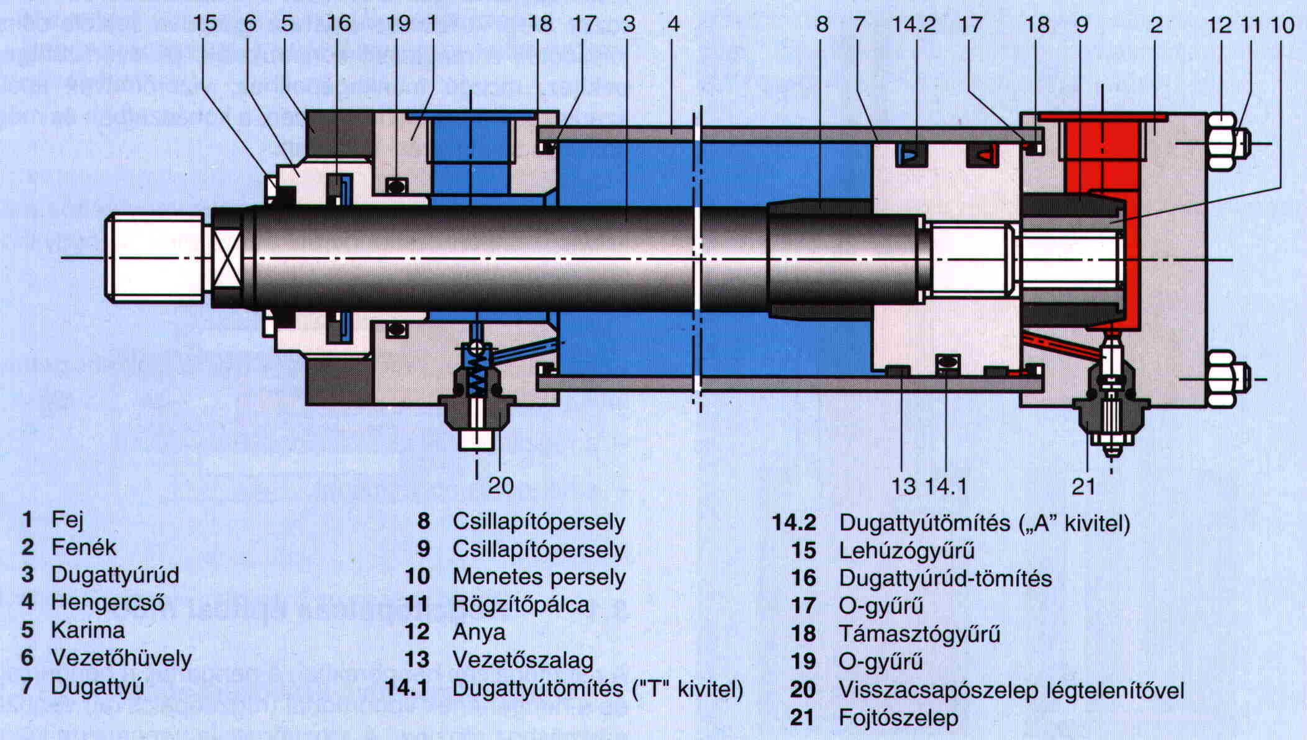

**Principle Used in Hydraulic Actuator System:**

**Pascal’s Law:**

Pressure applied to a confined fluid at any point is transmitted undiminished and equally throughout the fluid in all directions and acts upon every part of the confining vessel at right angles to its interior surfaces.

**Conservation of Energy:**

Since energy or power is always conserved, amplification in force must result in reduction of the fluid velocity. Indeed if the resultant force is applied over a larger area then a unit displacement of the area would cause a larger volumetric displacement than a unit displacement of the small area through which the generating force is applied. Thus, what is gained in force must be sacrificed in distance or speed and power would be conserved.

**Advantages of Hydraulic Actuation Systems:**

***Hydraulics*** refers to the means and mechanisms of transmitting power through liquids. The original power source for the hydraulic system is a prime mover such as an electric motor or an engine which drives the pump. However, the mechanical equipment cannot be coupled directly to the prime mover because the required control over the motion, necessary for industrial operations cannot be achieved. In terms of these Hydraulic Actuation Systems offer unique advantages, as given below.

***Variable Speed and Direction*:** Most large electric motors run at adjustable, but constant speeds. It is also the case for engines. The actuator (linear or rotary) of a hydraulic system, however, can be driven at speeds that vary by large amounts and fast, by varying the pump delivery or using a flow control valve. In addition, a hydraulic actuator can be reversed instantly while in full motion without damage. This is not possible for most other prime movers.

***Power-to-weight ratio*:** Hydraulic components, because of their high speed and pressure capabilities, can provide high power output with vary small weight and size, say, in comparison to electric system components. Note that in electric components, the size of equipment is mostly limited by the magnetic saturation limit of the iron. It is one of the reasons that hydraulic equipment finds wide usage in aircrafts, where dead-weight must be reduced to a minimum.

***Stall Condition and Overload Protection*:** A hydraulic actuator can be stalled without damage when overloaded, and will start up immediately when the load is reduced. The pressure relief valve in a hydraulic system protects it from overload damage. During stall, or when the load pressure exceeds the valve setting, pump delivery is directed to tank with definite limits to torque or force output. The only loss encountered is in terms of pump energy. On the contrary, stalling an electricmotor is likely to cause damage. Likewise, engines cannot be stalled without the necessity for restarting.

**Components of Hydraulic Actuation Systems:**

**Hydraulic Fluid:**

Hydraulic fluid must be essentially non-compressible to be able to transmit power instantaneously from one part of the system to another. At the same time, it should lubricate the moving parts to reduce friction loss and cool the components so that the heat generated does not lead to fire hazards. It also helps in removing the contaminants to filter. The most common liquid used in hydraulic systems is petroleum oil because it is only very slightly compressible. The other desirable property of oil is its lubricating ability. Finally, often, the fluid also acts as a seal against leakage inside a hydraulic component. The degree of closeness of the mechanical fit and the oil viscosity determines leakage rate.

**The Fluid Delivery Subsystem:**

It consists of the components that hold and carry the fluid from the pump to the actuator. It is made up of the following components.

**Reservoir:**

It holds the hydraulic fluid to be circulated and allows air entrapped in the fluid to escape. This is an important feature as the bulk modulus of the oil, which determines the stiffness of hydraulic system, deteriorates considerably in the presence of entrapped air bubbles. It also helps in dissipating heat.

**BOOT STRAP RESERVOIR:**

A bootstrap uses a differential area piston where high pressure hydraulic pressure from the pump outlet is applied to the small area of the piston. This produces a low pressure on the reservoir side of the piston. A major advantage of bootstrap reservoirs is that reservoir pressurization is maintained during aggressive flight maneuvers, including negative g flight. Additional hydraulic plumbing and some components are required for bootstrap reservoir implementation (see examples in System Design, Hydraulic Power Generation). Also, note the check valve in the high pressure line. The purpose of this check valve is to maintain reservoir pressure after the pump has shut down so that the pump inlet is maintained when the engine driven pump is not rotating. Accumulators may also be used in this circuit to assist in maintaining pump inlet pressure. The accumulator will be between the check valve and the reservoir.

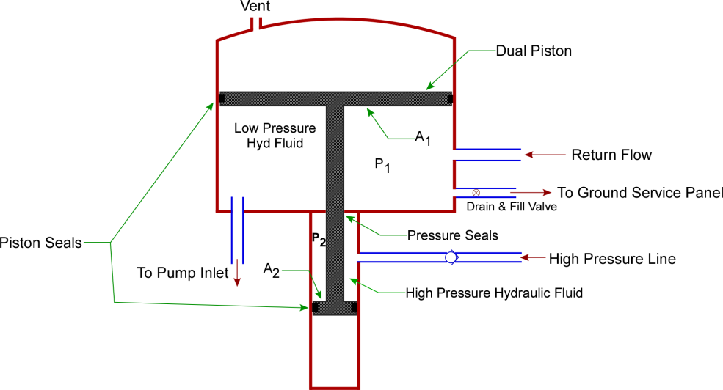



When the reservoir is at equilibrium P1A1 = P2A2. Since A1>> A2, P1<< P2. The differential piston areas are set by the pump nominal pump outlet pressure and the required level of reservoir fluid pressure.

**Operation:**

The hydraulic pump supplies system pressure to the reservoir connection and acts on the small piston. The force of this pressure is balanced by the induced pressure in the reservoir, which acts on the large main piston. For example, a bootstrap system can be designed so that a 3000 psi system pressure at the small piston will produce 85 psi of reservoir pressure. Depressing the bleed valve stem permits the inner chamber pressures to reduce to ambient pressure, thus bleeding off any entrapped air. The overboard relief valve protects the reservoir assembly from over pressurization.

**Design highlights:**

• High reliability

• Extensive service history

• Integrated bleed and relief valves

• Automatic bleed capability

• Visual and electrical level sensors

• Temperature compensated level sensor

• Isolation valves

• No external high-pressure leak paths

• Distribution manifold

• Compatible with phosphate ester- based and hydrocarbon-based (MIL-PRF-87257, 83282, 5606) operating fluids

**Filter:**

The hydraulic fluid is kept clean in the system with the help of filters and strainers. It removes minute particles from the fluid, which can cause blocking of the orifices of servo-valves or cause jamming of spools.

**Fittings and Seals:**

Various additional components are needed to join pipe or tube sections, create bends and also to prevent internal and external leakage in hydraulic systems. Although some amount of internal leakage is built-in, to provide lubrication, excessive internal leakage causes loss of pump power since high pressure fluid returns to the tank, without doing useful work. External leakage, on the other hand, causes loss of fluid and can create fire hazards, as well as fluid contamination. Various kinds of sealing components are employed in hydraulic systems to prevent leakage. A typical such component, known as the O-ring.

**SEALING BY O-RINGS:**

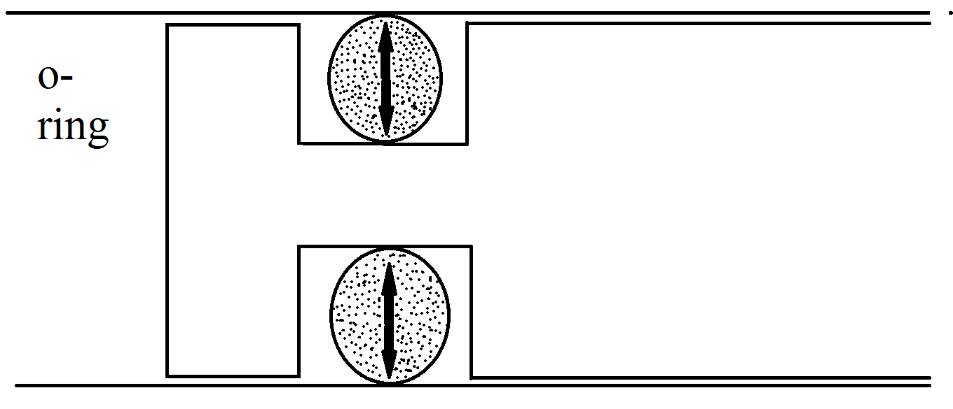

**Hydraulic Pumps:**

The pump converts the mechanical energy of its prime-mover to hydraulic energy by delivering a given quantity of hydraulic fluid at high pressure into the system. Generically, all pumps are divided into two categories, namely, hydrodynamic or non-positive displacement and hydrostatic or positive displacement. Hydraulic systems generally employ positive displacement pumps only. The symbol for a pump is

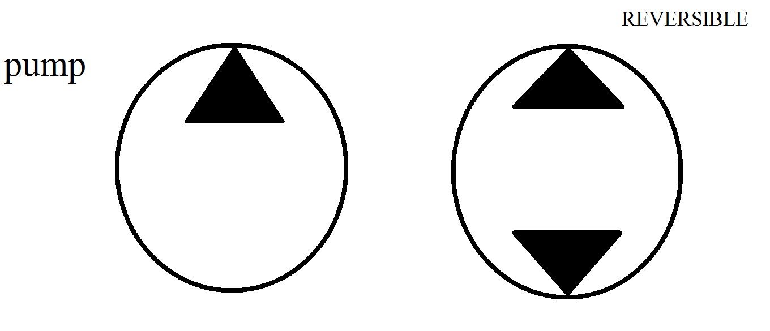

**Pumps types**

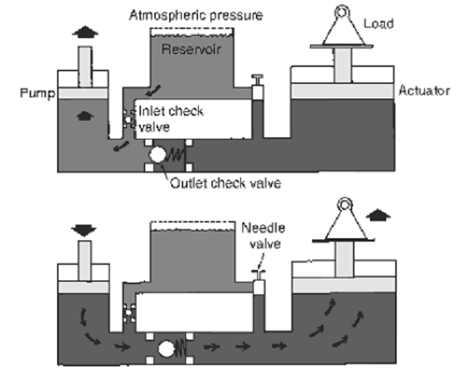

**Motors:**

Motors work exactly on the reverse principle of pumps. In motors fluid is forced into the motor from pump outlets at high pressure. These fluid pressures create the motion of the motor shaft and finally go out through the motor outlet port and return to tank. All three variants of motors, already described for pumps, namely Gear Motors, Vane Motors and Piston motors are in use.

**Accumulators:**

Unlike gases the fluids used in hydraulic systems cannot be compressed and stored to cater to sudden demands of high flow rates that cannot be supplied by the pump. An accumulator in a hydraulic system provides a means of storing these incompressible fluids under pressure created either by a spring, compressed a gas. Any tendency for pressure to drop at the inlet causes the spring or the gas to force the fluid back out, supplying the demand for flow rate.

**Spring-Loaded Accumulators:**

In a spring loaded accumulator, pressure is applied to the fluid by a coil spring behind the accumulator piston. The pressure is equal to the instantaneous spring force divided by the piston area. The pressure therefore is not constant since the spring force increases as fluid enters the chamber and decreases as it is discharged.

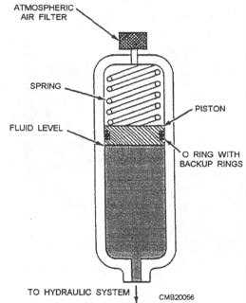

Spring loaded accumulators can be mounted in any position. The spring force, i.e., the pressure range is not easily adjusted, and where large quantities of fluid are spring size has to be very large.

**Gas Charged Accumulator:**

The most commonly used accumulator is one in which the chamber is pre-charged with an inert gas, such as dry nitrogen. A gas charged accumulator should be pre-charged while empty of hydraulic fluid. Accumulator pressure varies in proportion to the compression of the gas, increasing as pumped in and decreasing as it is expelled.

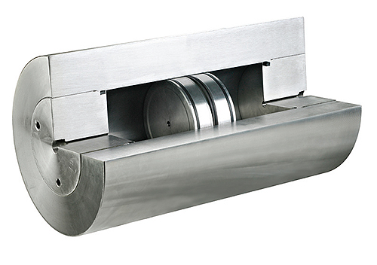

**GAS CHARGED ACCUMULATOR**

**Cylinders:**

Cylinders are linear actuators, that is, they produce straight-line motion and/or force. Cylinders are classified as single-or double-acting as illustrated in with the graphical symbol for each type.

**Properties:**

* The cylinders have to be good quality steel with close tolerances.
* There have to be good sealing both at the piston rod and at the cylinder.
* With time dirt may come in and damage the surfaces. This has to be possibly reduced.
* In this case, the leakage will increase all the time.

**Single Acting Cylinder:** It has only one fluid chamber and exerts force in only one direction. When mounted vertically, they often retract by the force of gravity on the load. Ram type cylinders are used in elevators, hydraulic jacks and hoists.

**PLUNGER USED IN SINGLE ACTING CYLINDER:**

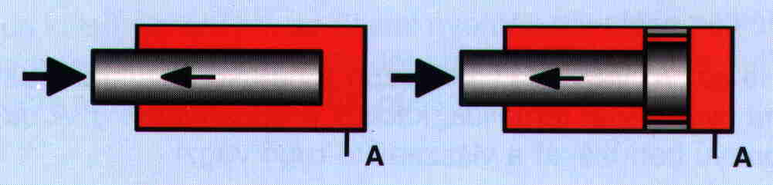

**PISTONS USED IN SINGLE ACTING CYLINDERS:**

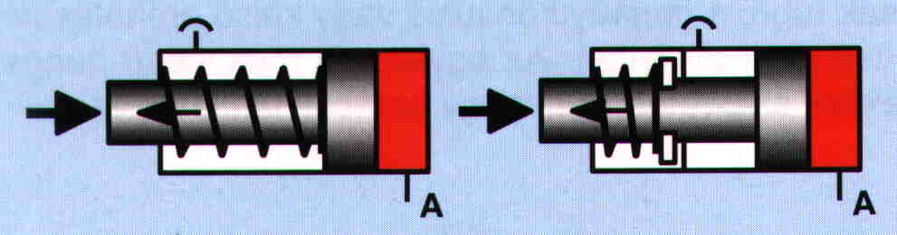

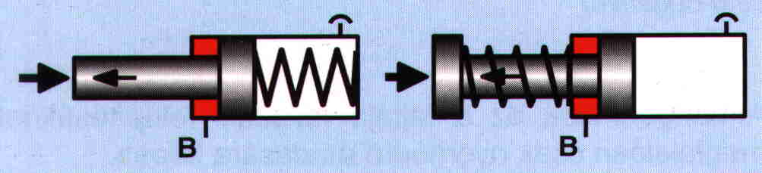

**Double-Acting Cylinder*:*** The double-acting cylinder is operated by hydraulic fluid in both directions and is capable of a power stroke either way. In single rod double-acting cylinder there are unequal areas exposed to pressure during the forward and return movements due to the cross-sectional area of the rod. The extending stroke is slower, but capable of exerting a greater force than when the piston and rod are being retracted.

**WORK IS DONE IN BOTH SIDES:**

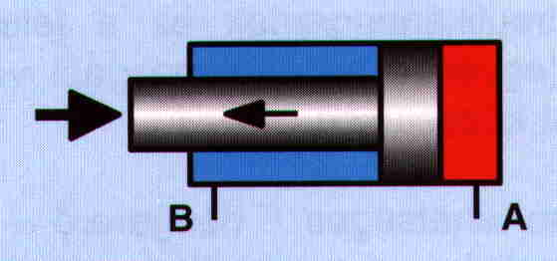

Double-rod double-acting cylinders are used where it is advantageous to couple a load to each end, or where equal displacement is needed on each end. With identical areas on either side of the piston, they can provide equal speeds and/or equal forces in either direction. Any double-acting cylinder may be used as a single-acting unit by draining the inactive end to tank.

**PISTON RODS ON BOTH SIDES:**

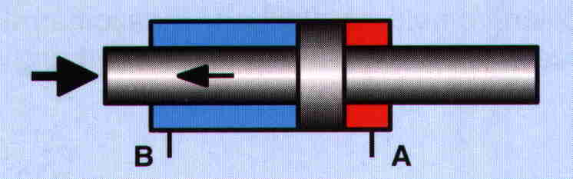

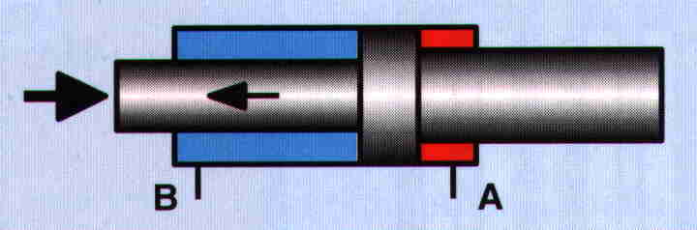

**SERVO VALVES:**

The servo valve in the missile is used to enhance the flow of fluid into the cylinder according to the desired movement of the piston in the cylinder. The movement of the sloop is controlled by the magnetic force developed by the armature. The sloop movement regulates the fluid flow according to the pressure needed to drive the piston.

It has to two oil control ports (c1 & c2) which are regulated by the sloop movement.

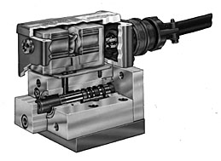

***CROSS SECTION OF SERVO VALVE***

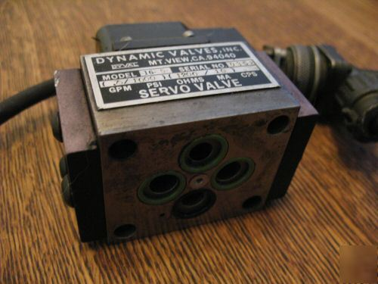

***SERVO VALVE***

A servo valve that is simple, rugged in design and dependable in performance to give superior system control and long trouble free operation.

**Principle of Operation:**

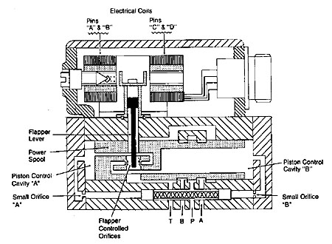

**Two-Stage Servo Valves:**

The primary stage of a two stage servo valve, shown in Figure "A", is a current driven device. Current in the coils produce a magnetic field which deflects the flapper lever an amount proportional to the current level and in the direction consistent with the direction of current flow.

The movement of the flapper lever upsets the pressure balance positioning the power spool. The power spool then repositions in the direction of the flapper lever so the pressure balance is again maintained.

Although the power of the flapper lever is very small, the hydraulic force amplification generated on the piston control cavities "A" and "B" is enough to accurately position the power spool.

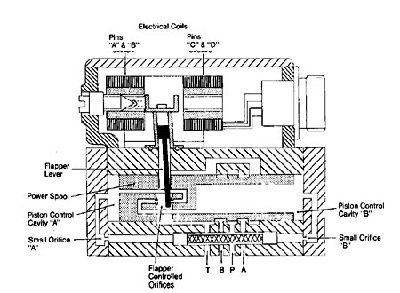

If a positive current flows from pin "A" and "C" to pin "B" and "D", the flapper lever will move to the right as shown in Figure "B". This movement of the flapper effectively throttles the nozzle on the right while de-throttling the nozzle on the left. The result is a pressure increase in cavity "A" which is supplied with fluid from the pressure port thru the small orifice "A". At the same time, the pressure in cavity "B" decreases as it is opened to tank "T" (drain).

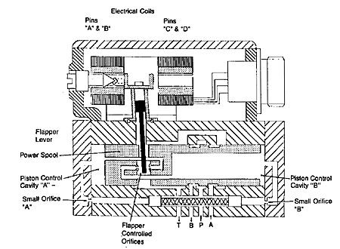

The pressure imbalance moves the power spool to the right until the flapper controlled nozzle gaps are equal and pressure in cavities "A" and "B" are once again equal as shown in figure "C". The repositioning of the power spool will to tank or drain port "T result in pressure port “P” being connected control port "B" and control port "A" connected to ".

By reversing the DC current direction from the above example, the flapper and main spool will move to the left and port "P" will be connected to control port "A" and control port "B" connected to tank "T" (drain).

**SOLENOID VALVE:**

A solenoid valve is an electromechanical device used for controlling liquid or gas flow. The solenoid valve is controlled by electrical current, which is run through a coil. When the coil is energized, a magnetic field is created, causing a plunger inside the coil to move. Depending on the design of the valve, the plunger will either open or close the valve. When electrical current is removed from the coil, the valve will return to its de-energized state.

In direct-acting solenoid valves, the plunger directly opens and closes an orifice inside the valve. In pilot-operated valves (also called the servo-type), the plunger opens and closes a pilot orifice. The inlet line pressure, which is led through the pilot orifice, opens and closes the valve seal.

The most common solenoid valve has two ports: an inlet port and an outlet port. Advanced designs may have three or more ports. Some designs utilize a manifold-type design.

Solenoid valves make automation of fluid and gas control possible. Modern solenoid valves offer fast operation, high reliability, long service life, and compact 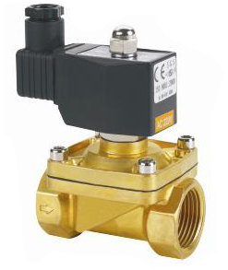design.

***PURPOSE OF HYDRAULIC ACTUATION SYSTEM IN MISSILES:***

**THRUST VECTOR CONTROL:**

The actuation system is used to guide the missile. The actuators are assembled to the engines such that the thrust created by the engines is properly guided and directed according to the pre-designed path of the missile.

Two actuators are attached to each of the cylinder such every motion is guided. The engines are designed in such a way that to direct the thrust in proper direction. The linkage mechanism is designed in such a way that it can move about 7degrees in the desired direction to align the missile in the designed path.

**Missile:**

In a modern [military](http://en.wikipedia.org/wiki/Military), a missile is a self-propelled [guided weapon](http://en.wikipedia.org/wiki/Guided_weapon) system. Missiles have four system components: targeting and/or guidance, flight system, engine, and warhead. Missiles come in types adapted for different purposes: surface-to-surface and air-to-surface (ballistic, cruise, anti-ship, anti-tank), surface-to-air (anti-aircraft and anti-ballistic), air-to-air, and anti-satellite missiles.

**Flight system:**

Whether a guided missile uses a targeting system, a guidance system or both, it needs a flight system. The flight system uses the data from the targeting or guidance system to maneuver the missile in flight, allowing it to counter inaccuracies in the missile or to follow a moving target. There are two main systems: vectored thrust (for missiles that are powered throughout the guidance phase of their flight) and aerodynamic maneuvering (wings, fins, canards, etc.).

**Thrust vectoring**, also **thrust vector control** or **TVC**, is the ability of an [aircraft](http://en.wikipedia.org/wiki/Aircraft), [rocket](http://en.wikipedia.org/wiki/Rocket), or other vehicle to manipulate the direction of the [thrust](http://en.wikipedia.org/wiki/Thrust) from its [engine](http://en.wikipedia.org/wiki/Engine)(s) or motor in order to [control](http://en.wikipedia.org/wiki/Flight_control) the [attitude](http://en.wikipedia.org/wiki/Attitude_dynamics_and_control) or [angular velocity](http://en.wikipedia.org/wiki/Angular_velocity) of the vehicle.

In [rocketry](http://en.wikipedia.org/wiki/Rocket) and [ballistic missiles](http://en.wikipedia.org/wiki/Ballistic_missile) that fly outside the atmosphere, aerodynamic [control surfaces](http://en.wikipedia.org/wiki/Flight_control_surfaces) are ineffective, so thrust vectoring is the primary means of [attitude control](http://en.wikipedia.org/wiki/Attitude_control)

For aircraft, the method was originally envisaged to provide upward vertical thrust as a means to give aircraft vertical ([VTOL](http://en.wikipedia.org/wiki/VTOL)) or short ([STOL](http://en.wikipedia.org/wiki/STOL)) takeoff and landing ability. Subsequently, it was realized that using vectored thrust in combat situations enabled aircraft to perform various maneuvers not available to conventional-engine planes. To perform turns, aircraft that use no thrust vectoring must rely on aerodynamic control surfaces only, such as [ailerons](http://en.wikipedia.org/wiki/Aileron) or [elevator](http://en.wikipedia.org/wiki/Elevator_%28aircraft%29); craft with vectoring must still use control surfaces, but to a lesser extent.

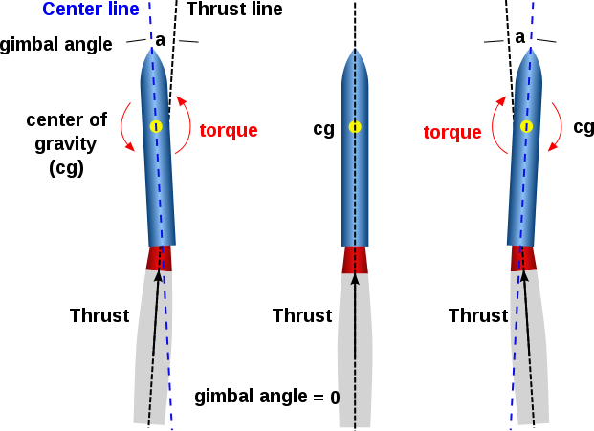

**AERODYNAMIC CONTROL (ADC):**

The aerodynamic control of the missile is maintaining the fin movements.

Most guided missiles are controlled and stabilized with movable control surfaces or fins that project from the sides of the missile, typically near its rearward end. The fins, or possibly only a portion of the fins in larger missiles, are normally of symmetrical cross section and are pivotally mounted in the airstream. When each fin is oriented parallel to the airstream, there is no control force exerted on the missile. By pivoting the fins to be oriented at an angle with respect to the airstream, there is a resulting control force exerted on the missile and its direction or roll orientation is changed.

The actuators provided to the fins are known as the fin actuators. The fin actuators control the fin movement as we design and path we require and the direction which we want.

Some missiles may fly as fast as several times the speed of sound, and therefore control movements of the fins must be accomplished quickly and smoothly in response to a control signal. Control operations and consequent movements of the fins may be updated continuously by the missile electronics or commanded as often as several thousand times per second by a digital computer. The actuator mechanism which converts the electrical command signals to physical movement of the control fins must respond at high rates to maintain the maneuverability and stability of the high speed missile, minimizing dynamic behavior which might otherwise cause the fin not to follow the command exactly.

Two types of fin actuator systems are generally in use today. They are electromechanical systems and fluidic systems. In the former, command signals are translated to physical movement by a sophisticated electric motor, typically with a precision gear train. In the latter, which include both hydraulic and pneumatic systems, the command signal controls pressurizing valves and release valves that regulate the pressure in a cylinder with a movable piston, causing the piston to slide back and forth with in the cylinder. A push rod extends out of the cylinder and is connected to a control fin output shaft upon which the fin is mounted.



A fin control actuator for missiles carried on aircraft has a device which locks the fin shaft against aerodynamic loads and prevents the transmission of these loads through the drive train. The fin shaft lock includes a plunger which has a cam having a locking portion for engaging the output shaft and preventing the output shaft from rotating in one direction when the plunger is in the locking position. The cam also has a camming portion for engaging the output shaft and pushing the plunger to the retracted position when the output shaft rotates in the opposite direction. The plunger is urged into the locking position by a spring and is held in the retracted position by a permanent magnet. The fin lock device is reusable and does not consume any power after it is set. Comprising in addition, solenoid means for remotely releasing the plunger from the retracted position.

The control actuator must be operable over a wide range of environmental conditions, including temperature, vibration, acceleration, and high structural and fin loadings. For example, some military specifications require that the missile be storable for extended periods and thereafter operable over temperatures ranging from as low as -65° F. to as high as +190° F. The actuator for the control surfaces must be made of materials that achieve satisfactory strength and other properties over the entire environmental range, and additionally must retain its performance in all specified environments.